Sprint Number #1

Members

Guy Dahan 208271734

Lior Elisberg 308032473

Mendel Amar 337790786

Eliran Dagan 208065180

Links

CircleCI: <https://app.circleci.com/pipelines/github/elirandagan>

Heroku: <https://dashboard.heroku.com/apps/project-management-company>

GitHub: <https://github.com/elirandagan/Project-Management-Personnel-Company>

Website: <http://project-management-company.herokuapp.com>

What did we have here?

At the Sprint we were asked to build the infrastructure and skeleton of a website, according to specific guidelines and by using platforms (CICD) to conduct a controlled process of building a website as is customary today.

Client Side:

We have created a main login page, through which it will be possible to access the home site (the user must first connect and then have access to the home page).

On the login page, we checked and validate that there are indeed values in the right places (Username & Password).

Server Side:

We checked that the server was responding correctly, and that the page we were requesting was indeed the page that was received.

Technologies:

Express.js, EJS files, SweetAlert.

Screen Shots

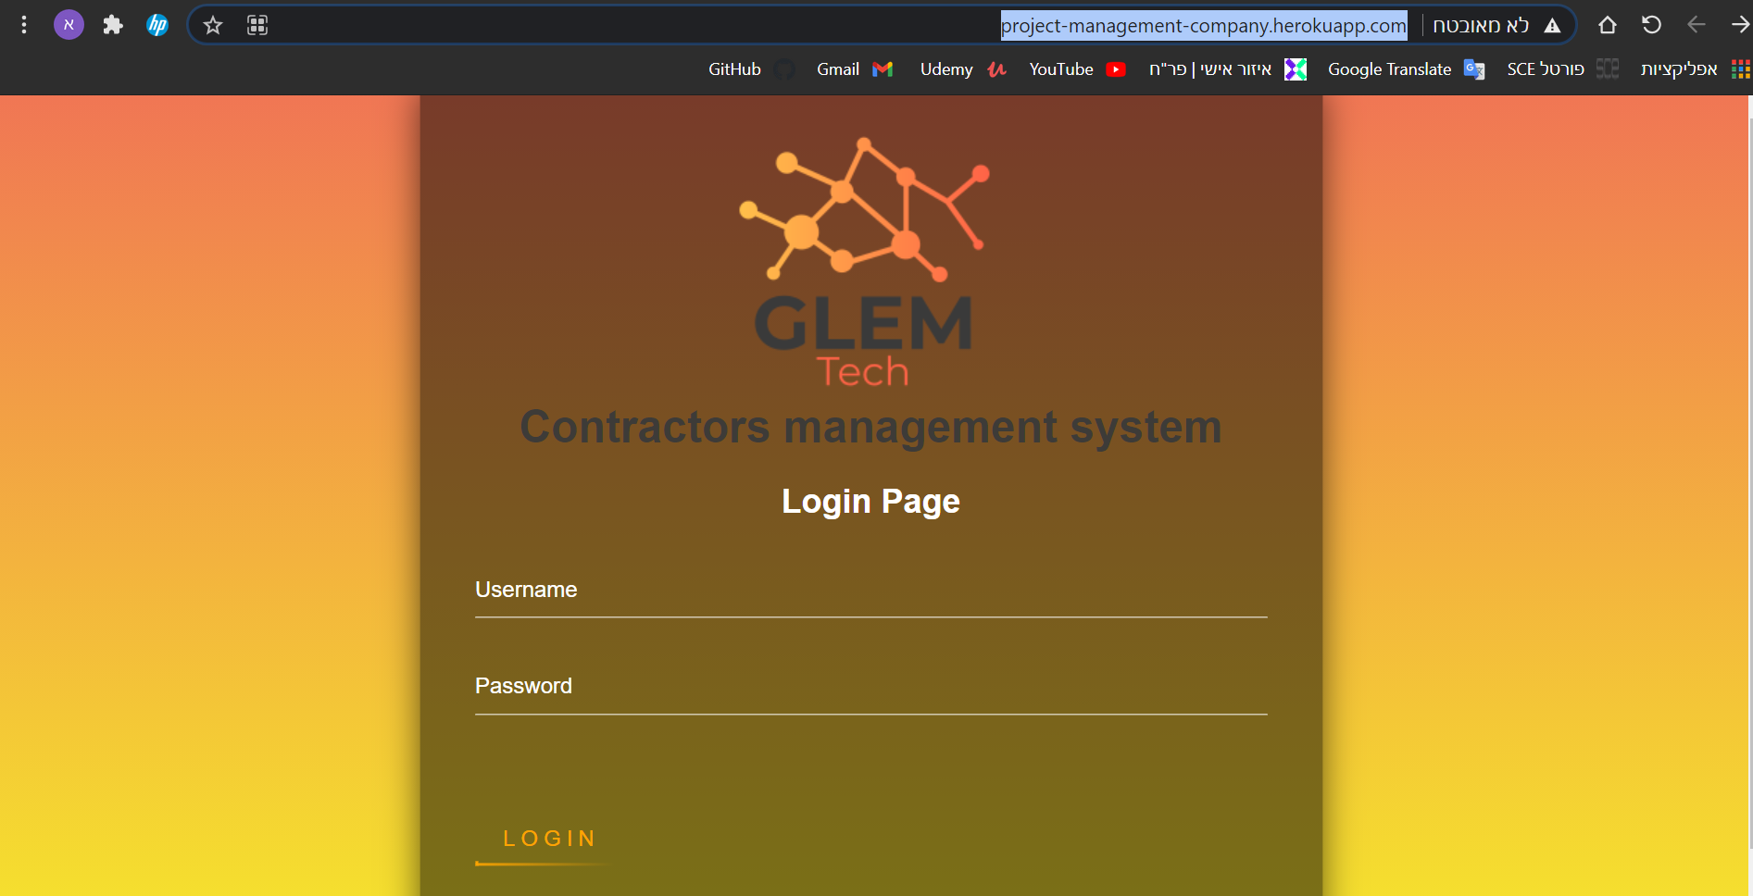

\*Login page – The landing page of our site.



\*Validation – Using "SweetAlert", validation check (offers the right Username and Password to get into the site).

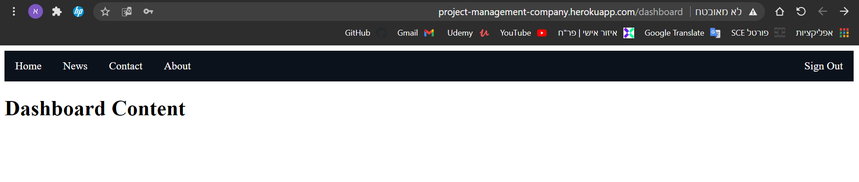\*Dashboard – After entering right Username and Password, by pusing the "Login" button this path will appear ("dashboard").

CICD

CircleCi

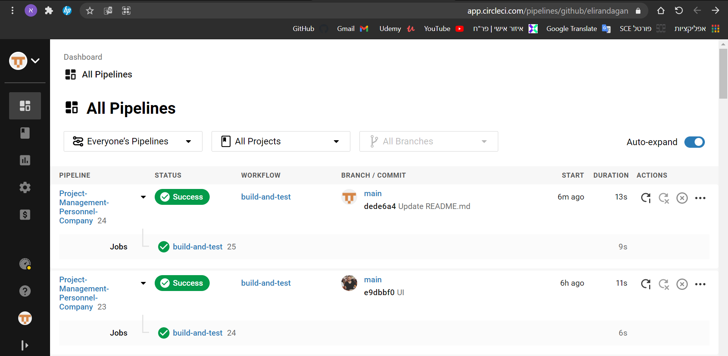

Heroku

